Sequence Diagram for logging in, creating or picking client, performing test and submitting test.

UML diagram for database:

**The ideal Originally designed UML diagram:**

**The current working version on the UML diagram:**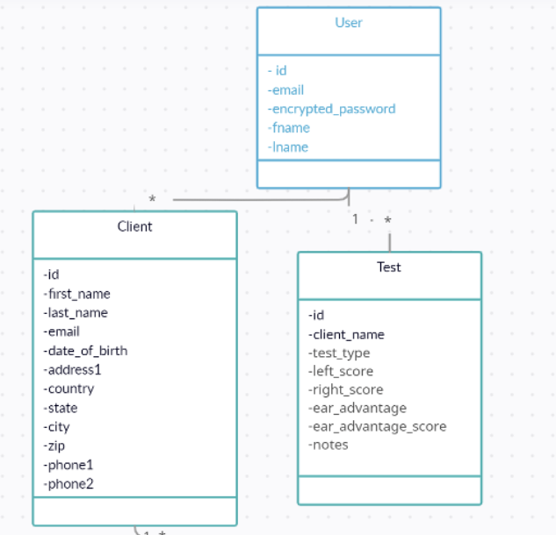



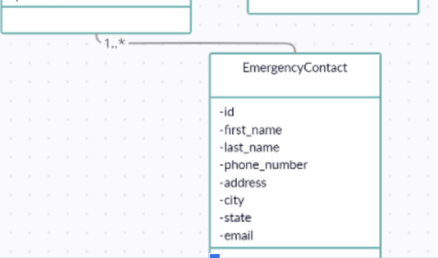

**Description:**

**User (Clinician)**

* Users, also known as Clinicians, are authorized to administer tests to Clients
  + Each User can have multiple Tests, and the relationship between a User and a Test indicates that the User administered the Test to a Client.
  + Users store personal and authentication information such as name, email, and password.

**Client**

* Clients represent the individuals receiving tests from the Users (Clinicians).
  + Each Client may have multiple EmergencyContacts and may take multiple Tests.
  + Clients store personal information such as name, contact details, and date of birth.

**EmergencyContact**

* EmergencyContacts are people who can be contacted in case of an emergency concerning a Client.
  + Each EmergencyContact is associated with a specific Client, and a Client can have multiple EmergencyContacts.
  + EmergencyContacts store personal information such as name, phone number, address, and email.

**Test**

* Tests represent the assessments given to Clients by Users (Clinicians).
  + Each Test is associated with a specific Client and the User who administered the test.
  + Tests store information such as the type of test, scores, and notes.

This is the current working version of the database, we originally designed it with more relations in mind but found other things more pressing to complete, it would likely be best to complete the UML as described if the group felt the need to. You may find that the clinician to client relation is unnecessary, feel free to omit or manipulate the relations at your own discretion.